

Fall Design Report

UAV Health Monitoring

Author:
Prissha Chawla
Siddharth Urankar
Ally Blair

Supervisor:
Dr. Manish Kumar
Dr. Manuel Arias Chao
Dr. Chetan Kulkarni
Luke Busse

Submission Date: November 25th, 2025

Contents
The Team 3
Team Members 3
Team Advisors 3
Project Abstract 3
Project Description 3
User Stories and Design Diagrams 4
User Stories 4
Design Diagrams 4
Project Tasks and Timeline 6
Task List 6
Milestones 8
Timeline 9
Timeline Gantt Chart 10
Effort Matrix 11
Effort Chart 12
ABET Concerns 13
Self-Assessment 14
Professional Biography 14
Prissha Chawla – Computer Science and Statistics 14
Siddharth Urankar – Computer Science 15
Ally Blair – Mechanical Engineering 15
Budget 16
Material Cost Breakdown 16
Appendix 16
Project Hours 16
Links 17
References: 18

The Team

Team Members
- Prissha Chawla [CS]
- Siddharth Urankar [CS]
- Ally Blair [ME]

Team Advisors
- Dr. Manish Kumar [UC ME]
- Dr. Manuel Arias Chao [ZHAW, Tu Delft]
- Dr. Chetan Kulkarni [NASA]
- Luke Busse [PhD Student at UC]

Project Abstract
This work presents a UAV powertrain health-monitoring framework that integrates a semi-supervised CNN autoencoder for early detection of motor acoustic anomalies with a supervised DeepONet that models battery degradation, predicts remaining useful life, and estimates flight time. Together, these models deliver real-time diagnostics to enhance reliability and safety in mission-critical operations.

Project Description
The aim of this project is to develop a UAV powertrain health monitoring framework that integrates hardware based acoustic sensing with machine learning driven diagnostics. The system will address two UAV subsystems: motors and batteries, which are among the most failure prone components in UAV operations.
The project involves building a UAV test platform equipped with USB microphones, current/voltage sensors, and a drone stand for controlled, repeatable, and safe testing. Microphone placement has been selected to balance signal to noise ratio so that both motor and propeller related faults can be captured. Data will be recorded in two ways: in a stand and while in flight to validate motor performance under realistic conditions. Multiple methods of recording motor and propeller sound will be designed and compared, along with a strain measuring system that will advise the health monitoring framework regarding structural stresses. Two models will be developed and integrated: a 1D CNN Autoencoder for semi supervised detection of motor and propeller anomalies from acoustic data, and a DeepONet for supervised battery degradation modeling, RUL prediction, and flight time estimation. Both models will be optimized for deployment on onboard computer hardware with a NVIDIA Jetson Nano used for in-flight computing.
The final system will offer anomaly detection and diagnostics while in flight. This project and the associated research directly enables integration into the IASMS by combining deep learning, mechanical design, and hardware sensing. This will enhance UAV safety and reliability for all applications.

User Stories and Design Diagrams
User stories portray some possible use cases of this work from a user’s perspective. The design diagrams start with level 0 [being the most basic and simple version] and go on to levels 2 and 3, that are increasingly detailed about the design of this work.

User Stories
1. As a UAV operator, I want to automatically detect motor or propeller faults during f light, so that I can ensure safe landing and prevent crashes in mission-critical operations.
2. As a drone fleet manager, I want to track battery health and predict remaining flight time, so that I can plan missions more reliably and reduce unexpected downtime.
3. As a remote operator using a drone-in-a-box system, I want in-flight monitoring of propeller damage, so that I can identify issues that are not visually observable and avoid risky deployments.
4. As a UAV maintenance technician, I want pre-flight diagnostics to flag potential motor or propeller issues, so that I can repair or replace components before they fail in operation.
5. As an aviation safety regulator, I want a standardized health monitoring framework integrated into UAVs, so that I can improve operational safety and ensure compliance with safety management systems.

Design Diagrams

Conventions
• Boxes represent a set of information, labelled where necessary such as input, output etc.
• Arrows represent transition from one box to the next, i.e., from one set of steps to the next.
• 2-sided arrows represent an extension of information provided by 1 box, in another box.
• Blue boxes and arrows represent the highest-level view of the design.
• Additional yellow boxes and arrows represent a lower-level view.
• Green boxes and arrows represent the lowest level view of the design.

Design Level 0
The following flowchart portrays this project in a simple input-output format using blue boxes and arrows.
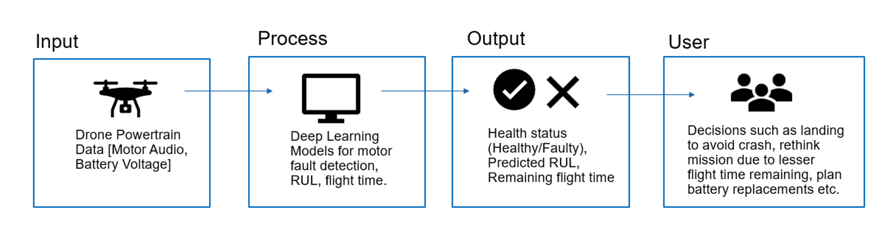

Design Level 1
This deeper design diagram builds upon the level 0 flow chart and adds detail using yellow boxes and arrows.
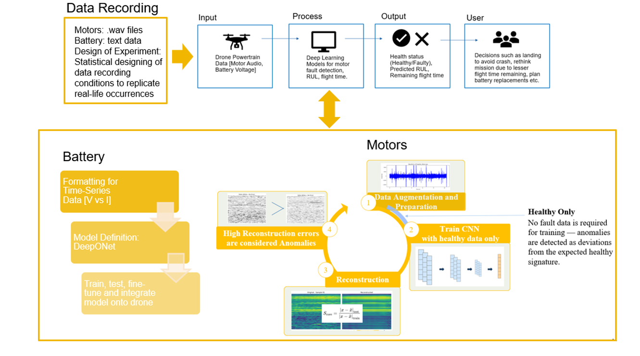

Design Level 2
Building further on the diagram from level 1, level 2 adds another layer of detail using green arrows and boxes.
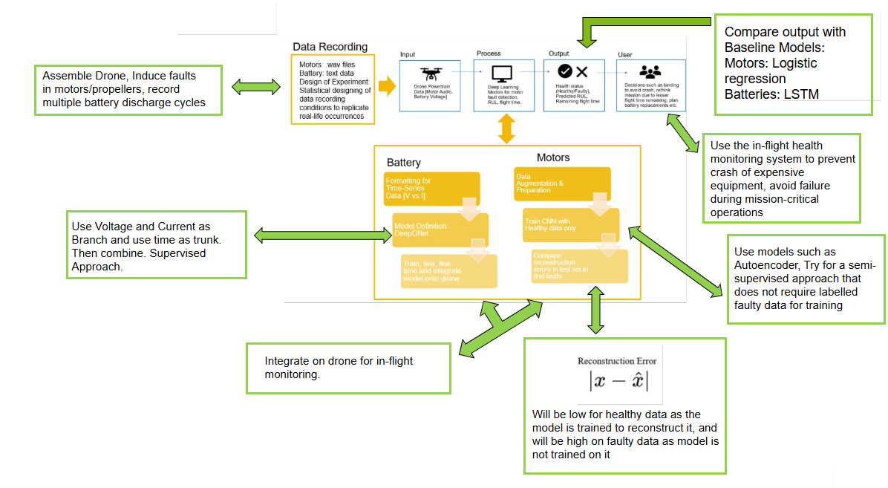

Project Tasks and Timeline

Task List
The tasks are grouped by the team member responsible for the task and each task is further broken down with a suitable description.

Ally Blair (ME) – Mechanical Systems, Data Collection
- Assemble UAV and test platform with stable mounting for motors and sensors.
- Conduct vibration isolation experiments to reduce structural noise in audio recordings.
- Compare microphone types (MEMS vs USB) under identical test conditions.
- Determine optimal microphone placement through controlled bench testing.
- Induce controlled propeller faults (e.g., chipped, unbalanced, bent blades) for dataset generation.
- Induce controlled motor faults (e.g., bearing wear, partial short) and record signatures.
- Establish safety protocols for running UAVs with faulty motors during testing.
- Record baseline healthy motor datasets across different operating conditions (RPM, load, environment).
- Record faulty motor datasets at varying fault severity levels for training/evaluation.
- Document mechanical test setup including fault induction procedures, mic placement diagrams, and UAV configuration.

Prissha Chawla (CS) – Data Science, AI, ML
- Design of experiment plan detailing recording scenarios, environmental variations, and repetitions.
- Perform exploratory data analysis (EDA) on collected motor audio datasets.
- Convert audio data into spectrograms and evaluate preprocessing pipelines.
- Develop semi-supervised autoencoder model for anomaly detection on healthy motor audio.
- Evaluate reconstruction error distributions to establish anomaly detection thresholds.
- Investigate supervised ML approaches (e.g., DeepONet or alternatives) for UAV battery health monitoring.
- Train and validate ML models using induced fault datasets and battery profiles.
- Conduct hyperparameter tuning for both autoencoder and supervised models.
- Benchmark model performance (precision, recall, F1) against UAV health monitoring objectives.
- Document AI methodology and results for inclusion in project reports and publications.

Siddharth Urankar (CS) – Software, Integration, Deployment
- Install and configure Linux OS on NVIDIA Jetson for UAV onboard computing.
- Develop microphone interface software to support synchronized acoustic data capture.
- Implement real-time data logging system for motor audio during UAV operation.
- Optimize data storage format for efficiency in transfer and later ML model use.
- Deploy trained autoencoder model onto Jetson for onboard inference.
- Develop anomaly detection pipeline that integrates audio capture with autoencoder output.
- Test latency and throughput of model inference on Jetson under flight-like conditions.
- Implement battery data collection interface for supervised RUL prediction model.
- Optimize Jetson codebase to balance recording, inference, and data transfer simultaneously.
- Validate end-to-end system integration by running real-time UAV health monitoring tests.

Milestones
# | Milestone | Description | Expected Completion
1 | Motor and Propeller Data Recording | Collection of baseline and faulty motor/propeller datasets under controlled lab conditions to support model training. | 8 Oct
2 | Initial Motor Model Developed | Development of first version of the motor health model using recorded data to detect motor faults and anomalies. | 22 Oct
3 | Integration on Jetson Hardware | Integrate initial motor model with onboard Jetson computer for in-flight real-time inference. | 29 Oct
4 | Battery Data Round 1 Collected | Perform first round of UAV battery discharge tests and record related performance metrics. | 24 Oct
5 | In-flight Motor Testing Conducted | Deploy and validate motor anomaly detection model in real flight-like environments. | 5 Nov
6 | Motor Model Fine-tuned | Improve accuracy and reduce false positives in motor fault detection through retraining. | 19 Nov
7 | Battery Model Prototyped | Develop an initial model for predicting battery health and remaining life using recorded data. | 28 Nov
8 | Strain Gauges & Second Drone Integrated | Implement strain gauges and secondary microphone array on second UAV for extended testing. | 3 Dec
9 | Extended Battery Data Collected | Conduct additional battery experiments to capture degradation trends under varying conditions. | 31 Dec
10 | Motor System Documentation Finalized | Prepare detailed documentation of test setup, model performance, and data pipeline. | 31 Dec
11 | Battery Model Fine-tuned and Validated | Finalize battery model and integrate results into UAV software for full system operation. | 20 Jan
12 | First Design Review Completed | Present first major checkpoint on progress, design, and model performance. | 1 Dec
13 | Second Design Review Completed | Present full system results and progress updates before final evaluation. | 20 Feb
14 | Final Report and Expo Presentation Prepared | Compile final report and prepare for Expo demonstration of UAV health monitoring system. | 7 Apr
15 | Final Report Submission | Submit detailed project report summarizing all development, testing, and evaluation results. | 24 Apr

Timeline
Task ID | Task Description | Start Date | End Date | Duration (days) | Milestone
A | Record motor and propeller data | 17-Sep | 8-Oct | 21 | M1
B | Create initial motor model | 8-Oct | 22-Oct | 14 | M2
C | Integrate motor model with Jetson | 22-Oct | 29-Oct | 7 | M3
D | Record round 1 battery data | 15-Oct | 24-Oct | 9 | M4
E | In-flight motor testing | 29-Oct | 5-Nov | 7 | M5
F | Fine-tune motor model | 7-Nov | 19-Nov | 12 | M6
G | Decision-making on battery discharge plan | 8-Oct | 13-Oct | 5 | M4
H | Build second drone | 22-Oct | 5-Nov | 14 | M8
I | Integrate and test second microphone array | 5-Nov | 19-Nov | 14 | M8
J | Round 2 battery data collection | 7-Nov | 14-Nov | 7 | M7
K | Create initial battery model | 19-Nov | 28-Nov | 9 | M7
L | Prepare for 1st Design Review | 24-Nov | 1-Dec | 7 | M12
M | Integrate strain gauges on second drone | 19-Nov | 3-Dec | 14 | M8
N | Further battery data collection | 1-Dec | 31-Dec | 30 | M9
O | Motor documentation | 1-Dec | 31-Dec | 30 | M10
P | Test and fine-tune battery model | 1-Jan | 20-Jan | 19 | M11
Q | Prepare for 2nd Design Review | 10-Feb | 20-Feb | 10 | M13
R | Write final report | 10-Feb | 24-Apr | 73 | M15
S | Expo preparation and participation | 24-Feb | 7-Apr | 42 | M14

Timeline Gantt Chart

Effort Matrix
Task ID | Task Description | Ally Blair (%) | Prissha Chawla (%) | Siddharth Urankar (%) | Primary Responsibility
A | Record motor and propeller data | 50 | 15 | 35 | Ally Blair
B | Create initial motor model | 10 | 80 | 10 | Prissha Chawla
C | Integrate motor model with Jetson | 10 | 10 | 80 | Siddharth Urankar
D | Record round 1 battery data | 50 | 30 | 20 | Ally Blair
E | In-flight motor testing | 40 | 20 | 40 | Siddharth Urankar
F | Fine-tune motor model | 10 | 80 | 10 | Prissha Chawla
G | Battery discharge planning | 20 | 60 | 20 | Prissha Chawla
H | Build second drone | 80 | 10 | 10 | Ally Blair
I | Integrate second microphone array | 70 | 10 | 20 | Ally Blair
J | Record round 2 battery data | 50 | 30 | 20 | Ally Blair
K | Create initial battery model | 10 | 80 | 10 | Prissha Chawla
L | Prepare for 1st Design Review | 33 | 33 | 34 | All
M | Integrate strain gauges on second drone | 70 | 10 | 20 | Ally Blair
N | Further battery data collection | 40 | 40 | 20 | Ally Blair
O | Motor documentation | 20 | 40 | 40 | Siddharth Urankar
P | Fine-tune battery model | 20 | 70 | 10 | Prissha Chawla
Q | Prepare for 2nd Design Review | 33 | 33 | 34 | All
R | Write final report | 33 | 33 | 34 | All
S | Expo preparation and presentation | 30 | 30 | 40 | Siddharth Urankar

Effort Chart
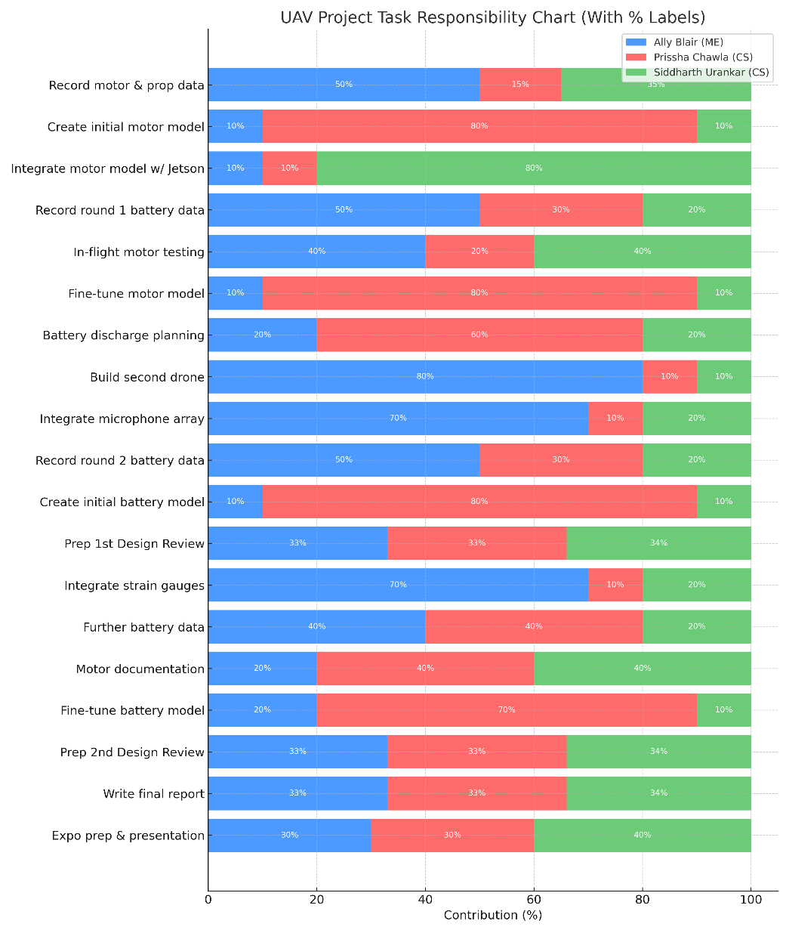

ABET Concerns
The development of an in-flight UAV powertrain health monitoring framework is shaped by several important constraints that influence both technical and non-technical design decisions. These constraints affect hardware selection, machine learning approach, testing procedures, and the overall scope of what can be achieved in the project. Addressing them carefully ensures that the final system remains feasible, safe, and aligned with real-world operational conditions.
Economic constraints are significant because this is an undergraduate project with limited funding. High-end microphones and specialized sensors such as those used at NASA by Dr. Kulkarni are not feasible to procure. Instead, cost-effective microphones and open-source software are being used, which impacts accuracy, scalability, and sensor fidelity.
Professional constraints also play a role because the project involves advanced mechanical engineering, sensor integration, and machine learning. This requires careful planning, disciplined execution, and maintaining engineering standards that reflect well on all collaborators and the institutions involved.
Ethical considerations are critical because the system is designed to detect faults in aerial vehicles. In real-world operations, detecting a healthy system as faulty is preferable to missing a fault and allowing a UAV to fly in unsafe conditions. Faulty real-world data is limited, and supervised models would likely bias toward healthy data due to class imbalance. A semi-supervised approach is therefore used to build a more reliable system that prioritizes safety over raw performance.
Legal constraints are relevant because UAV testing must comply with federal and institutional safety regulations. This limits where and when flight testing can occur and imposes strict requirements on flight procedures. Security is not a major technical constraint since the collected data will be made public, but UAVs are often deployed in security-sensitive applications. This raises the importance of safe operation in environments where drones may face interference or hazardous conditions.
Environmental and social factors influence the project through its expected benefits. By enabling early fault detection and predictive maintenance, the project aims to reduce crash risks, minimize environmental debris, and support more reliable UAV deployment in applications such as inspection, logistics, and emergency response. Diversity and cultural impact are represented through the interdisciplinary structure of the team. Meeting both mechanical engineering and computer science requirements adds coordination complexity, but also strengthens the project by combining different areas of expertise.
These constraints collectively shape the system’s design choices and research direction. By recognizing them early and building the project around realistic technical and operational boundaries, the team can deliver a solution that is safe, feasible, and impactful in real-world UAV applications.

Self-Assessment
As a Computer Science student with a minor in Mathematics and certifications in Software Engineering and Business Analytics, this project directly aligns with the technical skills and academic preparation I’ve built over the last three years. Most of my work on this project centers on software development, machine learning integration, and deploying our models onto the NVIDIA Jetson for real-time inference. My coursework in areas like Machine Learning, Artificial Intelligence, Computer Vision and Deep Learning gave me a strong foundation in supervised and semi-supervised methods, model evaluation, and understanding how data behaves under uncertainty. These courses also taught me how to connect theory to implementation, which is essential when the final system must work with real acoustic and battery data rather than controlled academic datasets.
My co-op and research experiences also contribute significantly to my role. Working at Marmon Holdings, the REACH Farmers Market project, and the XR Labs at the UC Digital Futures building taught me how to build reliable systems, manage real-world constraints, and communicate clearly with cross-disciplinary teams. These experiences improved my ability to break down complex technical work into smaller, testable pieces, something that is essential when integrating multiple sensors, real-time logging, and machine learning models on an embedded device. They also taught me the importance of documentation, version control, and consistency when writing software that others will use.
For this project, my main responsibilities include Jetson configuration, developing the real-time acoustic data logging pipeline, optimizing storage formats, and integrating both the autoencoder model and the DeepONet battery model onto the UAV. My work also involves testing inference latency, ensuring the system runs reliably under flight-like conditions, and validating our full pipeline from sensor to model output. The goal is to create a system that not only performs well in controlled experiments but is dependable in real-world environments, where noise, vibration, and unpredictable conditions exist.
I will evaluate my success in the project by looking at whether the software components I build remain stable when deployed, whether the Jetson can run both logging and inference without performance issues, and whether the final integration supports the team’s broader goals for motor and battery health monitoring. I will also judge my work based on the quality of documentation and whether future teams or collaborators can understand and build on what I have created. Overall, I see this project as an opportunity to bring together my academic preparation, real-world experience, and interest in AI-driven safety systems to contribute to a meaningful and technically challenging problem.

Professional Biography

Prissha Chawla – Computer Science and Statistics
- Student at the University of Cincinnati, B.S. Computer Science and Statistics, Certificates in Analytics and Cloud Computing, Expected Graduation: Spring 2026
- International experience: Exchange at ZHAW, Switzerland; NTUT PBL Robotics Workshop, Taiwan
- Co-op work experience: HR Analytics & Insights Co-Op, Delta Air Lines; Software Developer Co-Op, Procter & Gamble; Cloud Engineering Trainee, Hitachi Systems
- Skills: Python, R, SQL, deep learning frameworks (CNN, LSTM, DeepONet), predictive modeling, data wrangling, visualization, cloud services
- Project role: Development of 1D CNN autoencoder for motor anomaly detection, battery modeling, experiment design, exploratory data analysis, AI methodology documentation
Siddharth Urankar – Computer Science
- Student at the University of Cincinnati, B.S. Computer Science, Minor in Mathematics, Certificates in Software Engineering and Business Analytics, Expected Graduation: Spring 2026
- Studied abroad at ZHAW School of Engineering, Switzerland; participating in Ruhr Fellowship, Germany
- Interests: Artificial intelligence, software engineering, applications at the intersection of energy and financial systems
- Project role: Jetson integration, battery model development, software deployment
- Relevant experience: Python, PyTorch, computer vision, analytics tools, DeepONet and related pipelines for battery health monitoring and remaining flight time estimation

Ally Blair – Mechanical Engineering
- Student at the University of Cincinnati, B.S. Mechanical Engineering, Expected Graduation: Spring 2026
- Relevant experience: UAV assembly, sensor integration, vibration isolation, test stand design, electromechanical systems
- Skills: SolidWorks, Siemens NX, Autodesk Inventor, mechanical design, system integration, custom fixture and test system design
- Project role: Construction of UAV platforms, integration of microphones, strain gauges, and electrical sensors, mechanical testing and validation
- Other experience: Hands-on laboratory projects, interdisciplinary collaboration with software and AI teams

Budget
This project does not have a designated budget and as and when need arises for equipment, requests are filled in for approval. This project is being conducted at the UC’s Applied Autonomy Lab and all donations are from other projects being conducted at this lab under our advisor, Dr. Manish Kumar. Exact value of donated items is not known and it is harder to determine due to the nature of this project using damaged equipment [for anomaly detection].

Material Cost Breakdown
Item | Estimated Cost (USD) | Notes
USB microphones | 22 | Purchased
MEMS I2S microphones | 12 | Purchased
Breadboards and associated wires | 10 | Purchased
Strain gauges | 40 | Purchased
Thermocouple / Thermistor | 40 | Purchased
Additional sensors | TBD | To be acquired as needed
Lightly used, new, damaged propellers and BLDC motors | N/A | Donated from lab inventory
Components to build second UAV | N/A | Donated from lab inventory
NVIDIA Jetson Nano | N/A | Donated from lab inventory
Total New Material Costs | 124 | Excludes donated items

Appendix

Project Hours
These hours can be verified by our advisor Luke Busse who is in the lab on Wednesdays and Fridays, and other meetings can be justified by meeting notes and the faculty advisors themselves. ME Senior design section attendance can be verified by Dr. Jacob Cress. The hours put in by team members working remotely on their specified tasks and doing research or preparing for lab working sessions are not included here.

Team Member | Activity Description | Frequency/Duration | Total Hours
Siddharth Urankar | DF Lab work with team | 12 Wednesdays × 3 hr | 36
 | CS Senior Design Section Assignments | 0.5 hr/week × 14 weeks | 7
 | Friday project work | 3 Fridays × 3 hr | 9
Total |  |  | 52
Prissha Chawla | DF Lab work with team | 12 Wednesdays × 3 hr | 36
 | ME Senior Design Section | 8 Wednesdays × 2 hr | 16
 | Dr. Chao weekly meeting | 12 Wednesdays × 1 hr | 12
 | Dr. Kulkarni monthly meeting | ~3 hr | 3
 | Friday project work | 3 Fridays × 3 hr | 9
 | CS Senior Design Section Assignments | 0.5 hr/week × 14 weeks | 7
 | ME Senior Design Section Assignments | 0.25 hr/week × 14 weeks | 3.5
Total |  |  | 86.5
Ally Blair | DF Lab work with team | 12 Wednesdays × 3 hr | 36
 | ME Senior Design Section | 12 Wednesdays × 2 hr | 24
 | Check-in with Luke/Dr. Kumar | ~1 hr/week × 10 weeks | 10
 | Friday project work | 3 Fridays × 3 hr | 9
 | ME Senior Design Section Assignments | 0.5 hr/week × 14 weeks | 7
Total |  |  | 86

Links
Link to GitHub: Link
Link to OneDrive: Senior Design 1 - OneDrive

References:
​[1] | ​J. Novotňák, M. Fiľko, P. Lipovský and M. Šmelko, "Design of the System for Measuring UAV Parameters," Drones, vol. 6, no. 8, p. 17, 2022.
​[2] | ​. Y. Kato and M. Otaka, "Compressed Sensing of Vibration Signal for Fault Diagnosis of Bearings, Gears, and Propellers Under Speed Variation Conditions," Sensors, vol. 25, no. 10, p. 24, 2025.
​[3] | ​V. Alecsandri and S. cel Mare, "Finding fault types of BLDC motors within UAVs using machine," Heliyon, 2024.
​[4] | ​T. Zhao, Y. Zhang, M. Wang, W. Feng, S. Cao and G. Wang, "A Critical Review on the Battery System Reliability of Drone Systems," Drones, vol. 9, no. 8, p. 59, 2025.
​[5] | ​A. Theissler, J. Pérez-Velázquez and M. Kettelgerdes, "Predictive maintenance enabled by machine learning: Use cases and challenges in the automotive industry," Reliability Engineering & System Safety, vol. 215, 2021.
​[6] | ​X. Wang, D. Mao and X. Li, "Bearing fault diagnosis based on vibro-acoustic data fusion and 1D-CNN network," Measurement, vol. 173, 2021.
​[7] | ​S. Chen, J. Yu and S. Wang, "One-dimensional convolutional auto-encoder-based feature learning for fault diagnosis of multivariate processes," Journal of Process Control, vol. 87, 2018.
​[8] | ​M. J. Bianco, P. Gerstoft, J. Traer, E. R. Ozanich, M. A. Roch, S. Gannot, C. Deledalle and W. Li, "Machine learning in acoustics: Theory and applications," Acoustical Society of America, 2019.
​[9] | ​G. Lannace, G. Ciaburro and A. Trematerra, "Acoustical unmanned aerial vehicle detection in indoor scenarios using logistic regression model," Applied Acoustics, vol. 28, no. 1, 2020.
​[10] | ​F. Xiao, Y. Ding, X. Li, K. Zhang and J. Liu, "A CNN-LSTM Method Based on Voltage Deviation for Predicting the State of Health of Lithium-Ion Batteries," Bioengineering & Translational Engineering, vol. 4, no. 3, 2024.
​[11] | ​Y. Huang, X. Gong, Z. Lin and L. Xu, "A hybrid data-driven method for voltage state prediction and fault warning of Li-ion batteries," Case Studies in Thermal Engineering, vol. 64, 2024.
​[12] | ​J. Jeong, E. Kwak, J.-h. Kim and K.-Y. Oh, "Multiphysics-informed DeepONet of a lithium-ion battery to predict thermal runaway," PHM Society Asia-Pacific Conference, 2023.
​[13] | ​M. R. Niakan, S. S. Madani and M. Fowler, "Deep Learning-Based Battery Voltage Forecasting Using Current as Input: A Multi-Stage Approach for Time Series Prediction," IEEE, 2024.
​[14] | ​K. Oka, N. Tanibata, M. Nakayama, S. Noguchi, M. Karasuyama, Y. Fujiware and T. Miyuki, "Deep learning based emulator for predicting voltage behaviour in lithium ion batteries," Scientific Reports, vol. 14, 2024.

